Contents

Aerosol studies 2

Aerosol emissions from gas-liquid contactors devices 3

Methodology 4

Results and discussion 6

Economical 6

RLS 6

Cooling tower 9

Packed column 14

Discussion 18

Environmental 29

RLS 29

Cooling tower 29

Packed column 29

Discussion 29

Conclusion 29

Nomenclature 29

Appendix 31

Correlations plots 31

Experimental setups 33

External recources 35

References 35

# Aerosol studies

Gas/liquid contactors are being used in a variety of industries for decades. Gas-liquid contactors are being used to ease mass and/or heat transfer between a gas and a liquid. They are widely used in separation processes as strippers when components are removed from a liquid stream by a vapour stream, or scrubbers when removing solids or gases from a gas stream using the liquid phase. The simplicity, versatility and effectiveness of these contactors have made them very popular in many applications and in the discipline of chemical and biochemical engineering in which the gas, which is either in its pure shape or blended with other gases in a mixture, needs to be dissolved in the liquid phase [1]. Applications of such contactors include gas and oil refineries, wastewater treatment plants, chemical and petrochemical plants.

The working principle and efficiency of gas-liquid contactors have been studied quite extensively in the literature [2, 3]. One of the important aspects of the gas-liquid contactors that affects its efficiency and economy is the solvent loss or solvent emission [4] . Sovlent loss or drift (a term that is used in cooling tower systems) is defined as the liquid entrained in the air stream which is carried out of the contacor system through the induced draft fan stack. As in the presented study a cooling tower is compared with other contactors and since the solvent of interest does not have a vapour pressure, the term “drift” is used to define any solvent loss in the form of tiny droplets escaping the system. Drift in cooling towers contactors is the main cause of solvent loss [5, 6] and thus contributes to the overall efficacy of the contactor and imposes extra maintenance costs.

As mentioned above, drift is entrained solvent droplets in the tower discharge vapours. Drift loss varies between 0.1 and 0.2 % of Circulation flow. It can be as low as 0.01 % of circulation flow if the cooling tower has windage drift eliminators [7].

To minimise the drift, usually, a self-draining filter or a demister is implemented that removes solvent droplets from the stream and re-introduce the collected solvent to the solvent reservoir. However, no matter how high the efficiency of the demister/filter is, some of the solvents will be lost. On the other hand, there might be some particles within the nano/micrometre range that are small enough to be able to escape the filters and demisters. The loss due to the latter phenomenon is believed to be negligible and not contribute to significant economical outcome; however, it is of high significance in terms of adverse health and environmental effects [8].

Because the drift droplets contain the same chemical composition as the solvent circulating through the contactor, these droplets eventually can be converted to airborne particles [8, 9]. Large drift droplets settle out of the exhaust air stream and deposit near the exhaust vent. This process can lead to wetting, icing, salt deposition, and related problems such as damage to equipment or vegetation. Wet cooling tower emissions of PM10 can be computed using the EPA's AP-42 approach, which assumes that all total dissolved solids discharged in the form of drift are PM10 [10, 11].

The water content of airborne droplets may evaporate before being deposited in the area surrounding the exhaust falling within micro or even nanometre particle diameter range. Coarse and fine particles are emitted either directly from the gas-liquid contactors or when the water content of the larger droplets evaporates and leave fine particulate matter both in the form of concentrated solution or solid crystals within the micron and nano range [12]. Thus, the diameter of the particulate matter in the aerosol out of such contactors can vary over a few orders of magnitude ranging from a few nanometres for freshly generated particles to a few hundred microns for larger coarse droplets and agglomerated particles. The mechanical, physical and chemical properties of the particulate matter change over this wide range and thus it is of high importance to study the characteristics of different sized particles, formation, classification, growth and deposition mechanisms.

Larger particles contributes to solvent loss while smaller particles are more of an environmental concern.

# Aerosol emissions from gas-liquid contactors devices

This study presents comparisons of aerosol emissions of three different devices used to capture atmospheric carbon dioxide. All air capture devices investigated in this study can be classified as a form of gas-liquid contactor. A packed column (tested with both structured and random packings), a novel contactor, Rotating Liquid Sheet (RLS) [13] and a modified cooling tower are investigated in terms of particulate matter emissions subsequent solvent loss and potential environmental hazards.

Although factors affecting carbon dioxide absorption efficiency in packed columns are studied extensively[14, 15], aerosol emissions from packed columns has not been studied profoundly.

Aerosol emissions from cooling towers are studied in a number of studies [8, 16-18]. However, in this present study, the cooling tower is modified, and its application is changed. In all the mentioned references cooling tower is a form of heat exchanger and the coolant fluid is water and drift or windage is the water droplets that are carried out of the tower. In this study the cooling tower is modified to become a gas-liquid direct contactor. The water is replaced with a solvent having the ability to dissolve carbon dioxide. Since in this application the physical and chemical properties of the working fluid is completely different from that of a normal cooling tower, the aerosol emission characteristics of the devise will be altered and needs to be checked. On the other hand, since the rotating liquid sheet contactor is a novel design, it has not been tested for aerosol emission.

Based on the abovementioned, understanding the problems linked to aerosol emissions in gas-liquid contactors plants is less understood and it has not been investigated as profoundly as other parameters [6].

The emissions from gas-liquid contactors can occur via vapours, gases, and aerosols. Emission in the gaseous state is abundantly studied and regulated. Based on the literature the chemical composition of the solvent and the vapour pressure of the solvent are the two key factors determining new particle generation rates in the contactor [19]. It is believed that coarse particles (particle within the range of 2.5 microns to 10 microns) are mostly due to mechanical processes such as resuspended road dust, abrasive mechanical processes in industry and agriculture, some bioaerosols as well as agglomeration of smaller particles whereas particles between the range of 0.1 micron and 2.5 microns are caused as the result of both mechanical, physical and chemical processes like condensation, agglomeration, coagulation, seaspray and bubble burst [6, 20, 21].

Particles smaller than 0.1 micron are mainly direct result of combustion, secondary aerosol formation, photo oxidisation and nucleation [21, 22].

In accordance with the literature, it is highly improbable for the tested contactors to cause new particle formation smaller than 0.1 micron [21, 23].

The deposition and removal mechanisms of particles are different for different particle sizes. For particles larger than 10 microns gravitational sedimentation is the prevalent deposition mechanism. The effective removal method for particles within the size range of 0.5 to 5 microns is inertial impaction and Brownian diffusion are the main deposition mechanism for particles smaller than 0.1 micron[24]. Deposition efficiency for particles within the range of 0.1 to 0.5 is pretty low since they are too heavy for Brownian diffusion and also they are not heavy enough to be affected by inertial impaction or gravitational sedimentation and thus these particle will remain suspended in the aerosol for prolong period and can travel further away from the point of release and cause environmental and health problems. [20, 24] These particles will eventually collide with surfaces or make larger agglomeration particles or grow in size as the result of condensation and will be removed. However the removal process may take days and months to complete [25-27].

In the presented report, particulate matter from the mentioned gas-liquid contactors is measured. Particles within the size range of 10 nm to 10 microns are measured to be able to investigate the potential health and environmental hazards of the contactors and compare contactors in terms of solvent loss and, hence running costs.

# Methodology

All three contactors suck in atmospheric air. Air goes through the contactor where it is exposed to the solvent. Some of the carbon dioxide in the air is dissolved in the solvent and air exits the contactor after passing through a dosimeter or a cyclone. The demister and cyclone remove the larger entrained solvent particles/droplets from the air and reintroduce it to the solvent reservoir. Temperature and humidity of air is continuously recorded both at the inlet and outlet of the devices. A variable speed blower is used to move the air in and out of the contactors. Air velocity is measured at the inlet and outlet of the contactors. A centrifugal pump with magnetic drive is used to pump the solvent and deliver it to the distributor system. The pump is coupled with a VFD and the flow rate of the solvent is monitored and recorded.

Three different instruments were used to measure number concentration, size distribution and mass concentration of aerosols that are being emitted from the air capture devices.

Figure 1 shows a schematic of the cooling tower experimental setup. The setups corresponding to the packed column and RLS can be found in the appendix section.

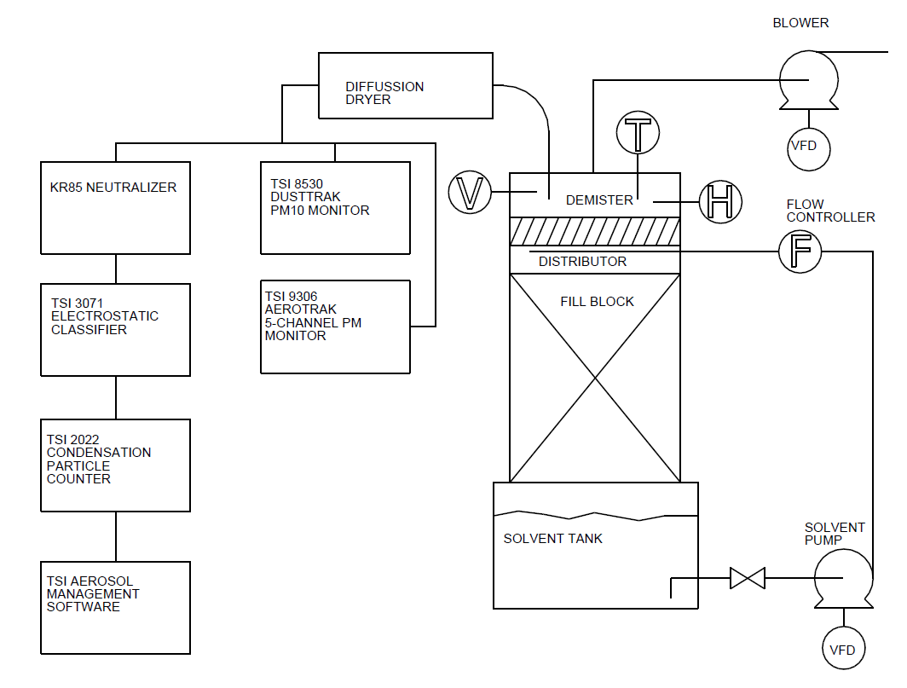

Figure , cooling tower experimental setup

The instruments can measure three characteristic attributes of the particulate matter within an aerosol:

* Particle size (diameter)
* Particle number concentration
* Particle mass concentration

An isokinetic probe is used to sample particulate matter from the exhaust system to the aerosol measurement devices [28]. A diffusion dryer is used to remove excess humidity and prevent condensations in the measurement system.

A TSI Scanning Mobility Particle Sizer (SMPS), consisting of a condensation particle counter (CPC TSI 2022) and an electrostatic classifier (EC TSI 3071), is used to measure the number concentration and size distribution of particulate matter in the aerosol [29]. Also using SMPS data, the particle mass concentration can be estimated by making a few simple assumptions [30].

A TSI Dusttrak 8530 is used to measure particulate matter mass concentration. The device uses different impactors enabling the user to measure PM1, PM2.5 and PM10. For the present study, only the PM2.5 and PM10 impactors are used; for smaller particles, SMPS can yield more accurate and more precise data [30].

A TSI Aero Trak 9306 is used to collect data on particulate matter mass and size distribution and number concentration [31].

R programming language [32] and R Studio interface [33] are used to carry out data analysis on the collected data. Link to the Git Hub repository to access all codes and data that is used to generate results can be found in the appendix section.

# Results and discussion

In this section, the results of the experiments carried out on the three different gas-liquid contactors are presented and discussed. The results of the experiments are discussed and compared from two different aspects: economic and environmental. Particles larger than 300 nm are the main contributors to the solvent loss and thus the maintenance and ongoing costs of the process. Particles smaller than 300 nm can travel much farther and suspend in the atmosphere much longer. They are also able to pass through the airways of the air-breathing creatures and cause health issues.

## Economical

More than 90 percent of the particulate matter mass are due to particles larger than 2.5 micron [34, 35]. Particles larger than 10 microns are effectively removed from the exhaust system implementing conventional demisters or cyclones [30]. So, in this study the main contributor to solvent loss is considered particles within the range of 2.5 to 10 microns.

### RLS

The first air capture device to investigate is the innovative Rotating Liquid Sheet (RLS). The device uses a rotating slotted tube to project sheets of liquid in a spiral form, and thus RLS does not use any type of packing; the air gets into contact with very thin rotating sheets of the solvent and because the sheets are spiral and spinning, they also result in a pumping effect which lowers the pressure drop across the whole system [13].

The correlation between different parameters were checked using (PPMCC) method [36, 37]. The color-coded plot showing the correlations can be found in the Appendix section. This study investigates meaningful PPMCC correlations with an absolute value of greater than 0.5.

Figure 2 shows the effect of air flowrate on the solvent drift. The vertical axis shows the fraction mass of solvent that escapes the contactor per unit mass of solvent in the contactor. The grey area shows the 95% confidence interval. The graph shows that the air flowrate has a slight effect on the drift; however, the limited number of experiments carried out on RLS makes it difficult to decide whether the effect is statistically significant. A second-degree polynomial smoothing line seems to show a decline in the solvent drift with increasing air flowrate. The RLS was equipped with a cyclone scrubber to remove large droplets in the outlet, which may be the key reason why the drift does not change considerably or decreases with increasing intake air velocity.

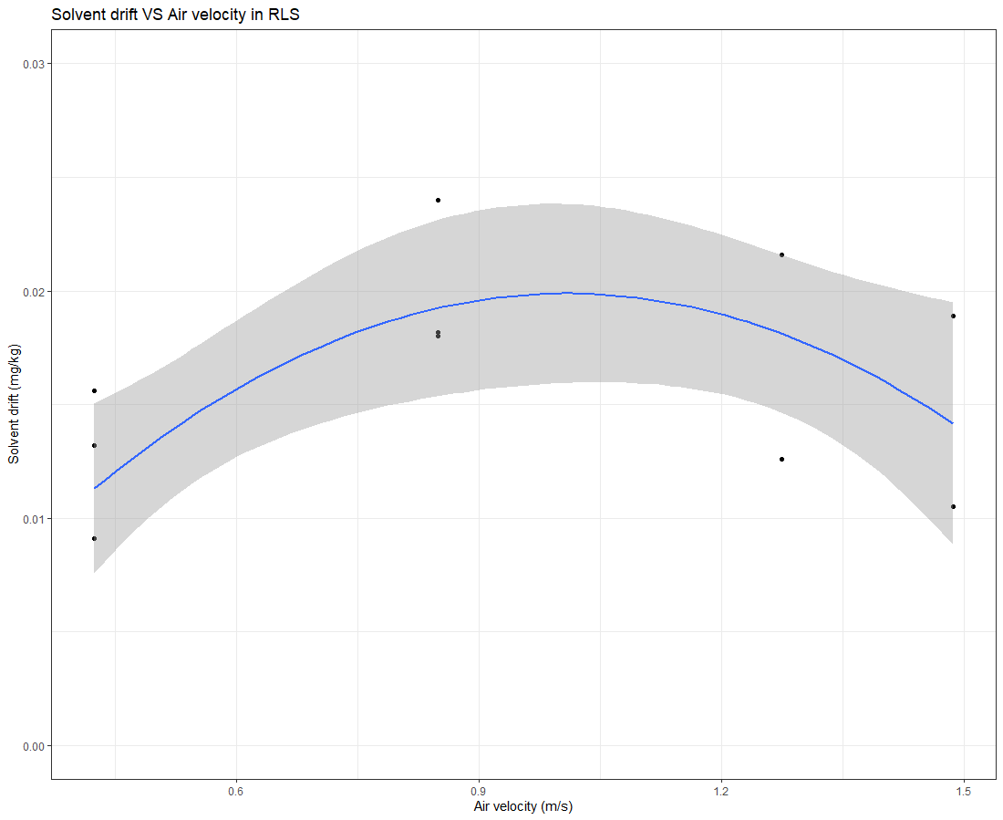

Figure Effect of intake air velocity on the solvent drift in RLS

Figure 3 shows PM10 emissions in the outlet of RLS. As air velocity increases more volume of air passes through the device and also noting the centrifugal force is proportional to the square of the velocity, implying that a doubling of speed will require four times the centripetal force to keep the motion in a circle. So when the velocity of air going through the cyclone increases the larger and heavier particles are removed more effectively in the cyclone. As mentioned above, the most effective removal mechanisms for particles larger than 5 microns are impaction and gravitational sedimentation. The cyclone works based on centrifugal force on the particles. The centrifugal force increases with the increasing air flowrate and thus particles are collected more effectively in the cyclone. This effect is well studied in the previous literature [38-40].

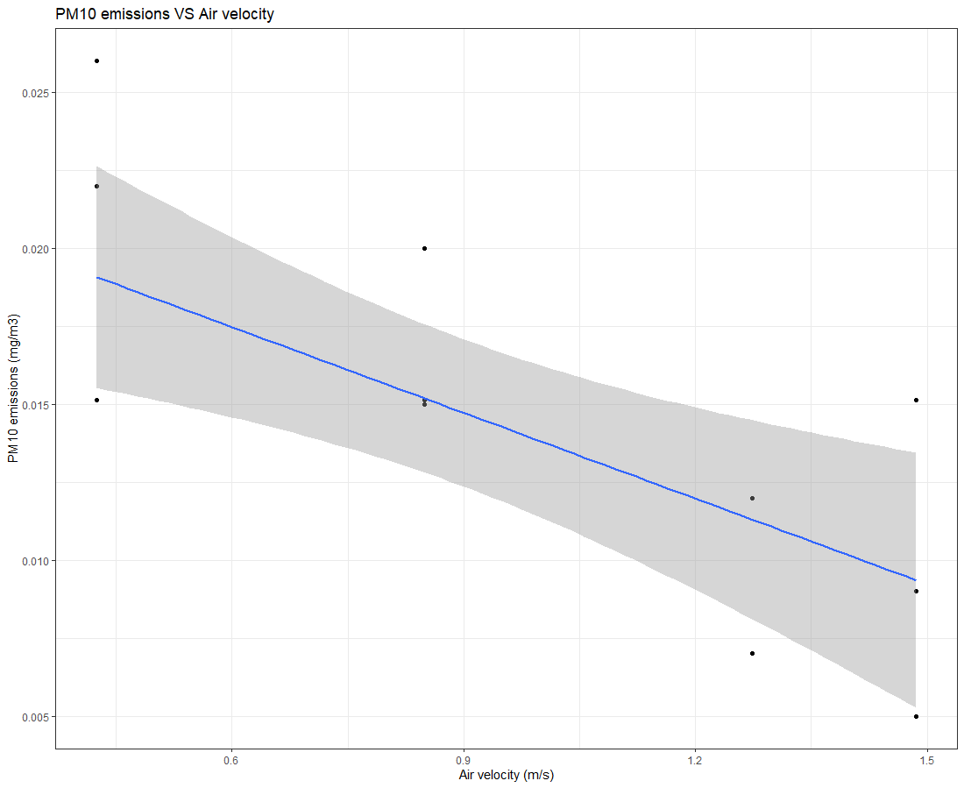

Figure effect of intake air velocity on PM10 emissions

Other correlations that can be observed in figure 1 are not worth a deeper study as they are either not within the scope of this study or they are not statistically important or they are not meaningful.

### Cooling tower

As mentioned before, a cooling tower is modified to be able to use as a gas-liquid contactor transfer mass instead of heat. A two molar solution of taurate is used in the cooling tower on order to capture CO2 from air.

A correlation network graph using PPMCC method is used to perform the initial exploratory analysis on the data acquired from the cooling tower. The graph can be found in the appendix section.

A number of different distributor systems are checked and compared in terms of maximum coverage and maximum effective contact surface area. Photos of the different types of distributors can be seen the appendix section.

Figure 5 shows the effect of distributor type, x-axis, on the PM10 emissions of the cooling tower, on the y-axis. Three types of distributors were tested for the aerosol experiments:

* a full cone random single nozzle (fc),
* a distributor made of four hollow-cone nozzles, (hc, the original design)
* and a spinning three-arm sprinkler (sp_3arm).

The boxplot shows that the full cone nozzle caused more PM10 followed by the hollow cone and the sprinkler. The full cone system caused almost four times higher PM10 than the sprinkler although the operating flowrate of both was almost identical at around 5 lit/min. It must be mentioned that PM10 does not include the flowrate of air in the system. The higher PM10 caused by the full-cone nozzle may be due to the smaller droplets and more coverage compared with the two other systems.

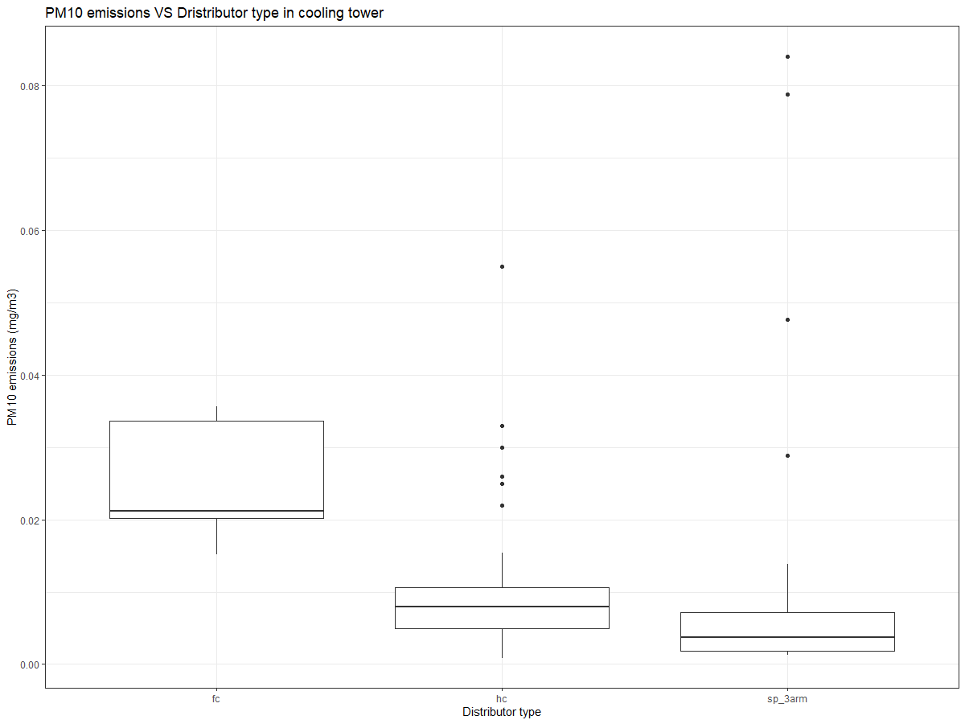

Figure Effect of distributor type on PM10 emissions from the cooling tower

Figure 6 shows the percentage of solvent drift against intake air velocity and categorized by the two different fill-blocks used in the cooling tower. As expected, the drift increases with the increasing intake air velocity. The fill-block-n shows a more pronounced correlation with air velocity that the original fill-block.

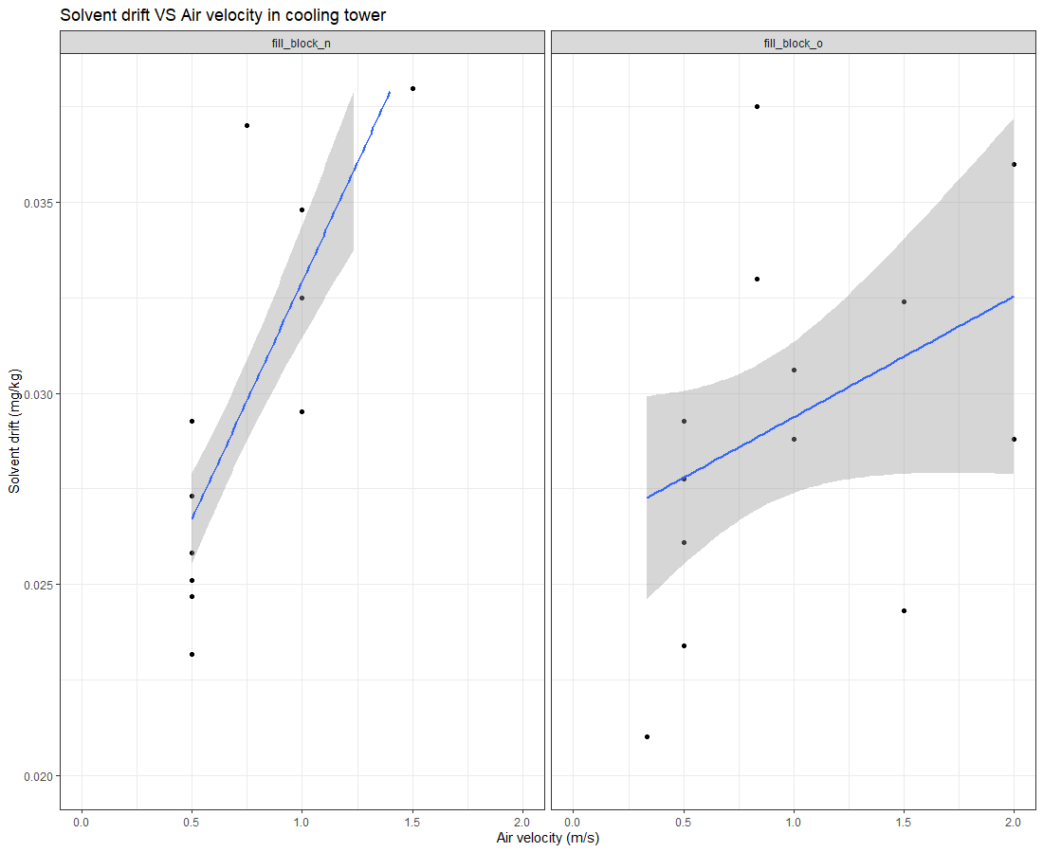

Figure Effect of intake air velocity on solvent drift for two fill-blocks in the cooling tower

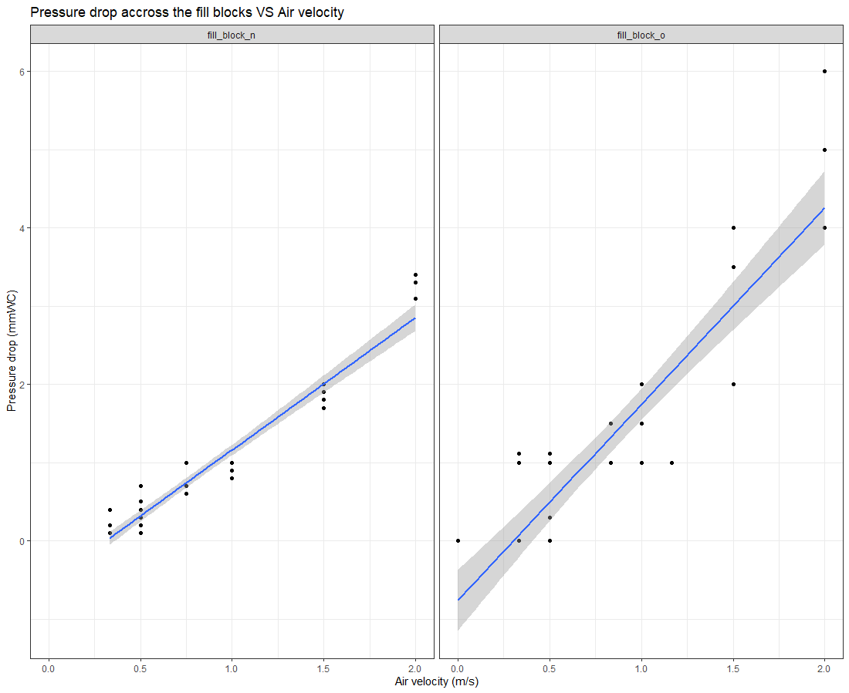

Figure , Pressure drop VS air flowrate across the original and new fill bocks

Figure 7 shows the PM10 emissions for the cooling tower for the used fill-blocks and distributors. Interestingly, the slope of the stat-smooth line is almost the same in all four cases. The three distributor types tested in the experiments were quite different in terms of droplet size. The full cone random single nozzle system (fc) caused the smallest droplets and the three-arm rotating sprinkler (sp_sarm) caused the largest solvent droplets, yet all distributors acted quite similar in terms of PM10 emissions. One possible explanation would be the fact that the cooling tower was equipped with a demister being able to effectively remove the larger droplets.

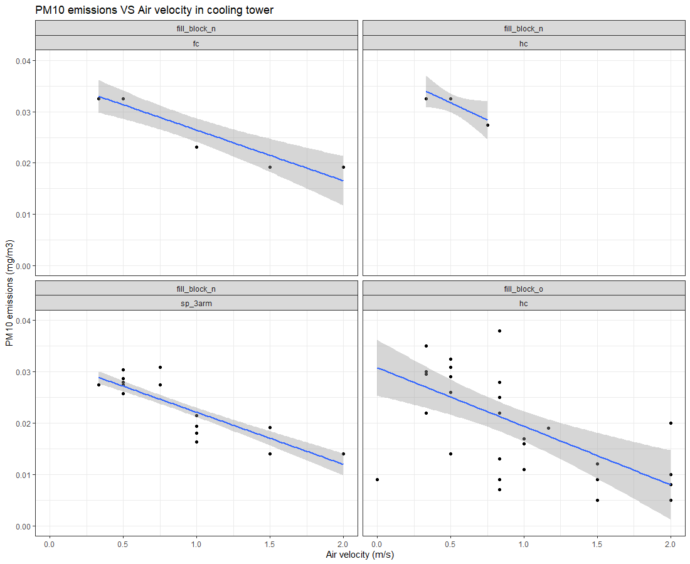

Figure Effect of intake air velocity on PM10 emissions for two fill-blocks in the cooling tower

Figure 8 shows the effect of absorption liquid flowrate on PM10 and PM2.5 emissions from the cooling tower. It seems that flowrate does not correlate with the PM10 emissions. Again the efficacy of the demister in removing larger droplets is probably the reason why particulate matter emissions stayed steady across the wide range of solvent flowrates. Figure 9 presents the drift percentage as a function of solvent flowrate, and here again, a drift stayed almost the same while the solvent flow rate is changing from 3 (lit/min) to 55 (lit/min)

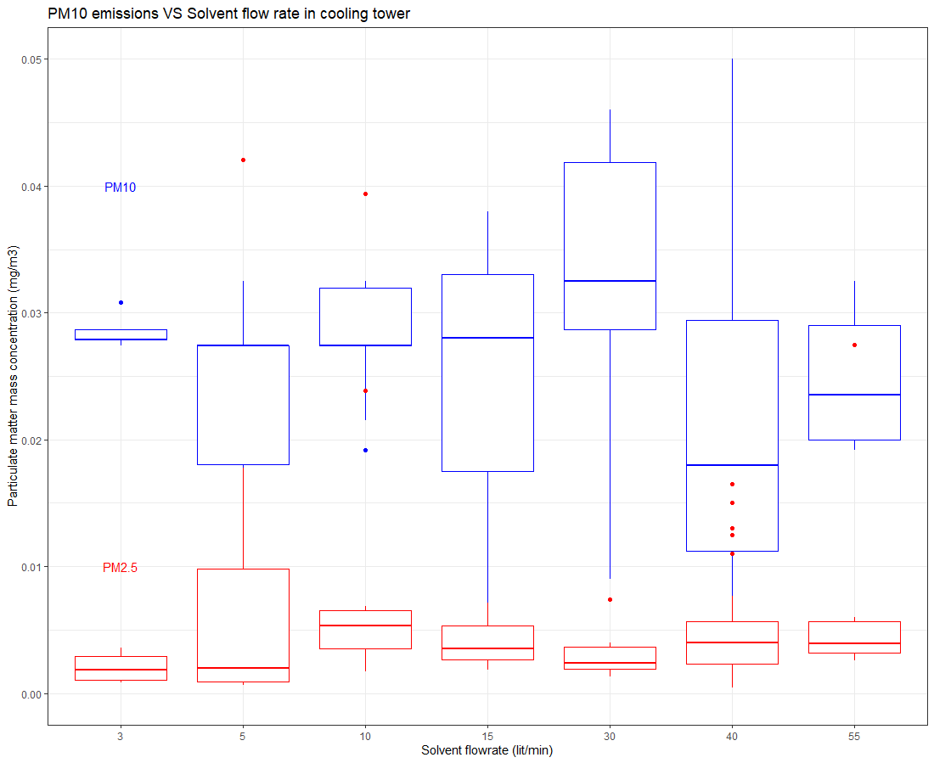

Figure Effect of solvent flowrate on the particulate matter emissions

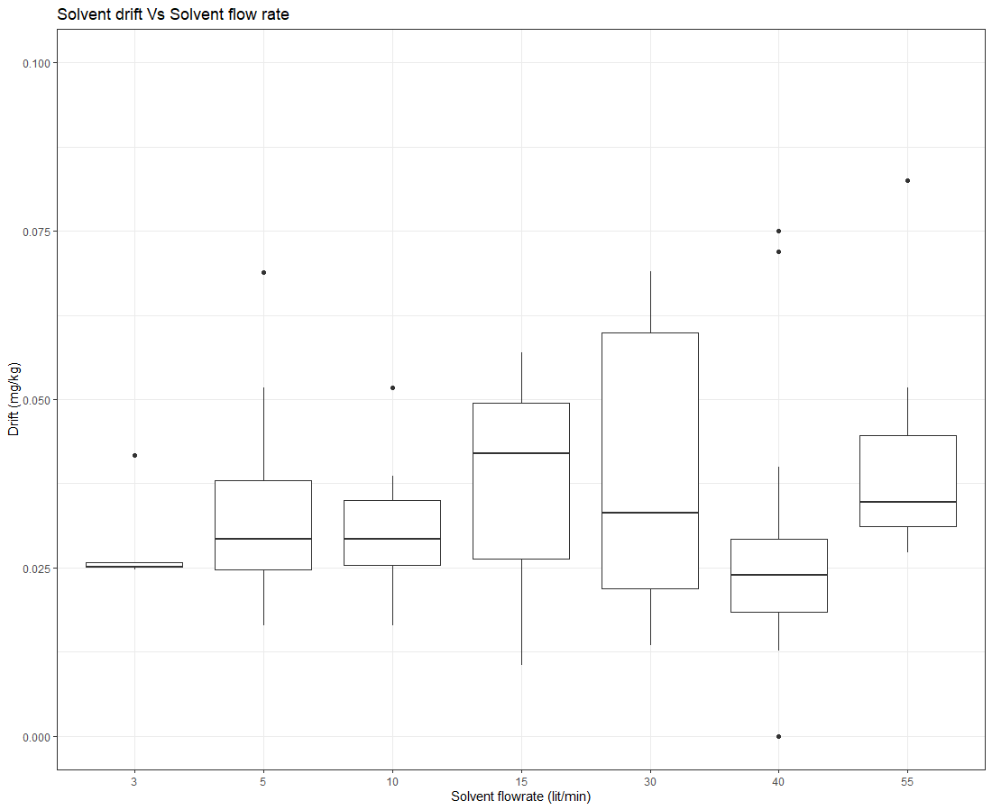

Figure Effect of solvent flowrate of the drift

### Packed column

Figure 10 depicts the correlation network for recorded variables in the packed column. Two solvents were used, hence the strong correlation between medium and ph. Solvent flow rate (fliq) shows a positive correlation with the amount of carbon dioxide absorbed (co2diff). Three different packings were used and it is shown in the network that the type of packing has a statistically significant effect on the carbon dioxide absorption, drift and pressure drop across the packing (dp). The variations in the abovementioned can be attributed to the type of packings and the fact that they provided different effective surface areas for the solvent and gas to contact.

For this part of the experiments, stainless packings (ss304), high-flow plastic packings (pp) and a prototype structured packing (cp) made by Curtin University are compared.

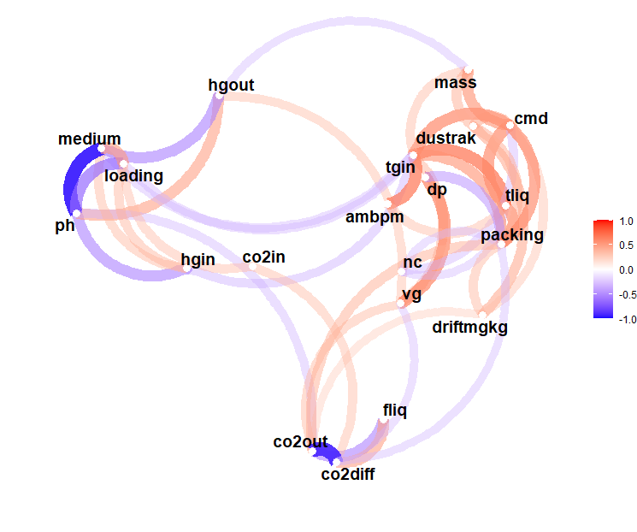

Figure Correlations between variables in the packed column

Figure 11 shows the pressure drop across the packing with respect to the air velocity. Stainless steel packing (ss304) has the most effective surface area and thus caused the highest pressure drop, followed by the plastic packings and Cutin University structured packing.

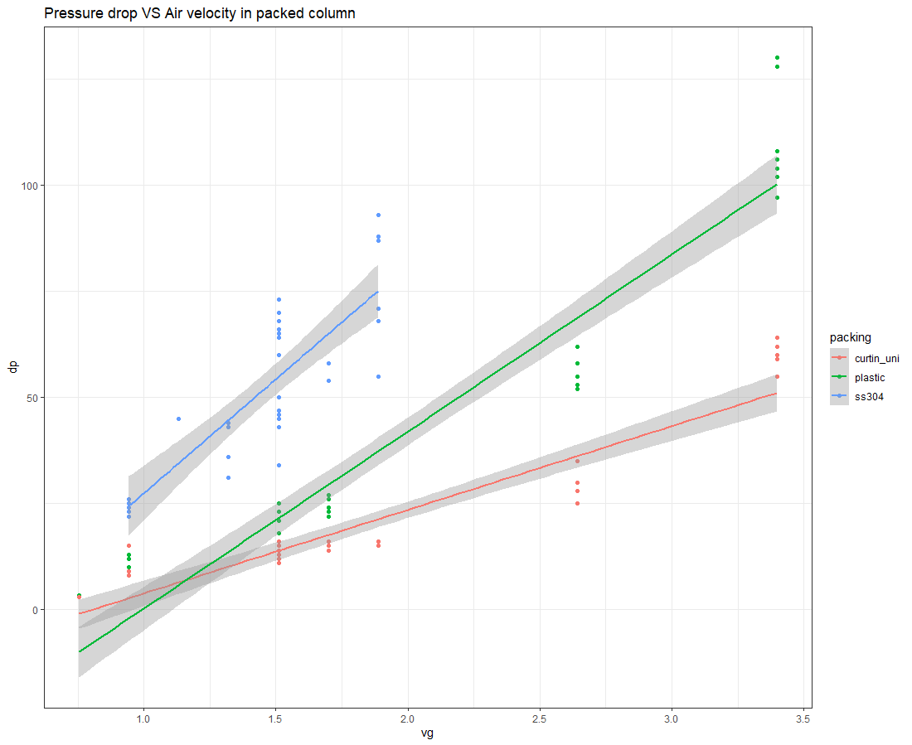

Figure , effect of air velocity on pressure drop across the packings

Figure 12 shows solvent drift against solvent flowrate and for different tested packings. It can be seen from the figures that although the Curtin University packing has the lowest pressure drop, it causes the highest solvent drift comparing to stainless steel packing and plastic packing. The reason behind this observation is yet to discuss and needs a more profound investigation.

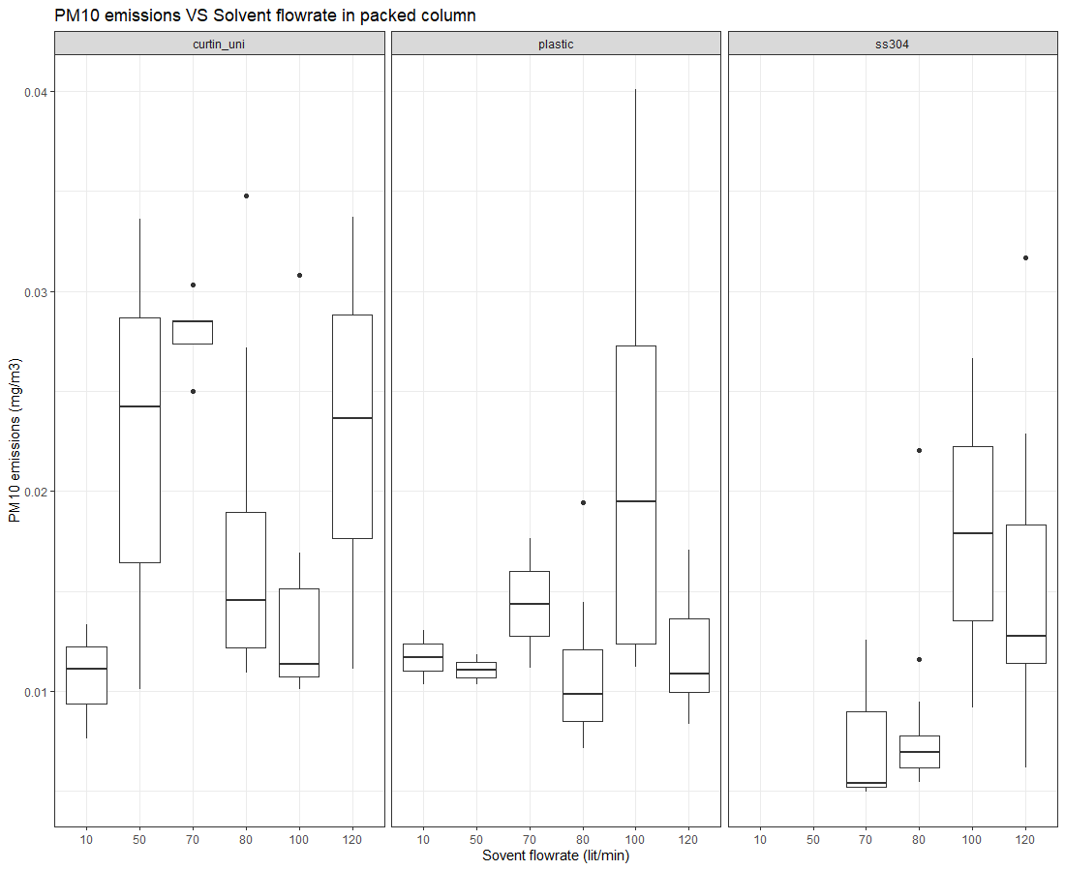

Figure , effect of solvent flowrate on solvent drift for different packings

Figure 13 shows the effect of air velocity and type of packing on the solvent drift. Much like the previous figure, while stainless packing and plastic packing were virtually in the same order in terms of solvent drift, the Curtin University structured packing caused almost twice as much drift for the same air velocity.

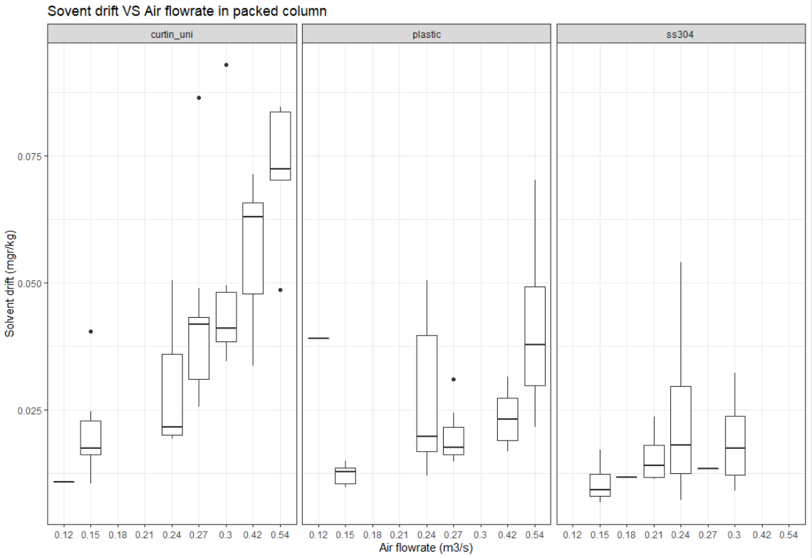Figure , effect of air velocity and type of packing on solvent drift from the packed column

### Discussion

Now that all three types of gas to liquid contactors are studied one by one, this section tries to compare some of the performance characteristics of the contactors.

An interesting correction was observed between the number concentration of particles in the outlet of contactors and ambient CO2 (nc and CO2in). The correlation is real and statistically significant. But a more profound investigation showed that the correlation is due to the traffic in the surrounding area. When there is more traffic the concentrating of CO2 goes up and also the number concentration of nanoparticles increases.

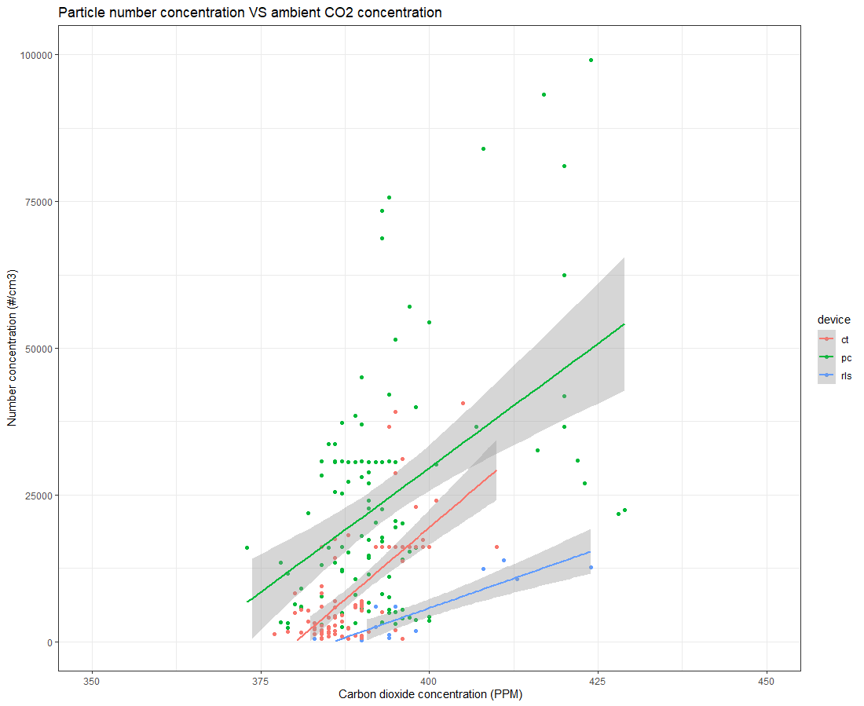

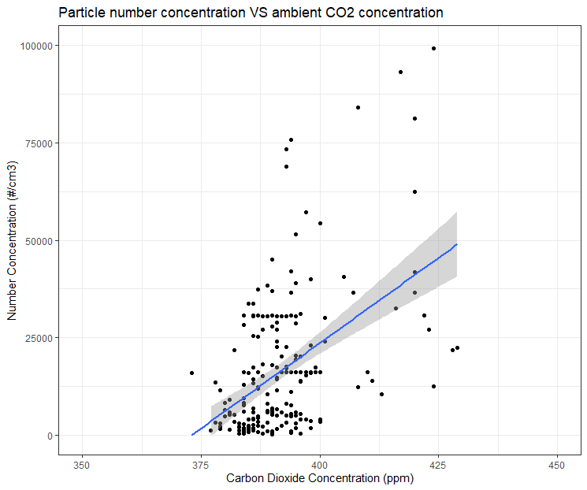

Figure , correlation between ambient carbon dioxide on particle count

Figure 16 shows the total particle number concentration of the three contractors. It shows that the packed column caused considerably more particles followed by the cooling tower and RLS. One reason for this observation is the fact that the packed column with random packing provided the largest surface area and caused the highest pressure drop. On the contrary in RLS, where packings or fill-blocks are non-existent, caused the lowest pressure-drop, and smallest surface area and the least number of particles.

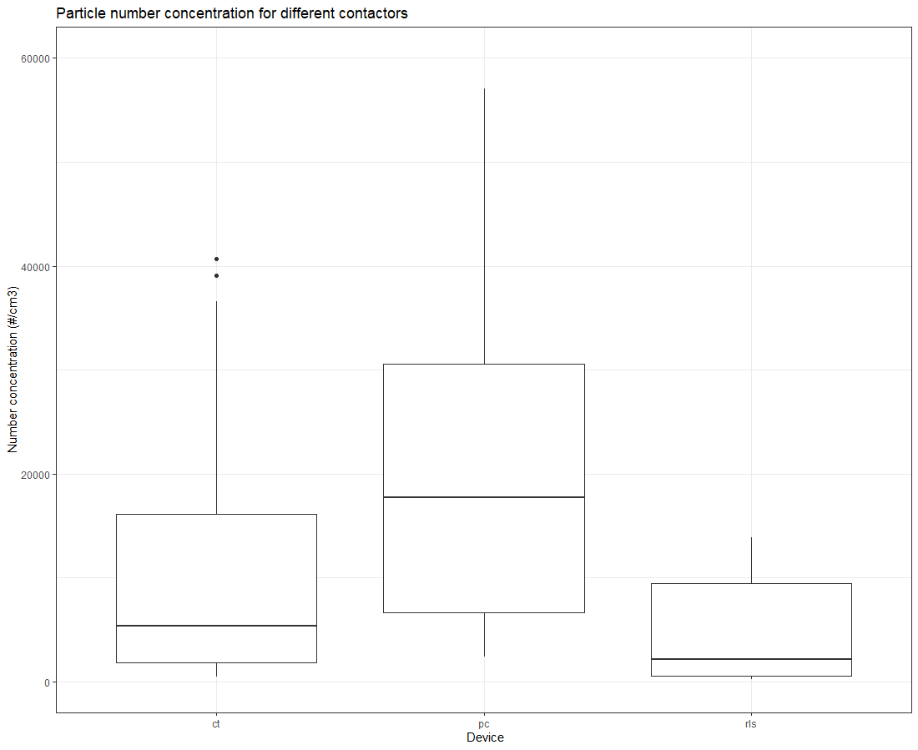

Figure , the effect of using different air capture devices on nanoparticle count

Figure 17 compares the contactors in terms of solvent drift. Although the cooling tower resulted in a fewer number of particles, the drift out of the cooling tower was more than the packed column and RLS. Here it is important to point out that 90 per cent of the particle count comes from the particles that are smaller than 100 nm and interestingly they contribute to 10 per cent of the total mass of the particulate matter emitted. it seems that because both RLS and packed column were equipped with a cyclone, the larger droplets were effectively removed from the out-going stream while smaller particles escaped the cyclone. Whereas in the cooling tower, the demister was not able to remove larger particles as effectively. Perhaps if the height of the demister is increased it can perform better.

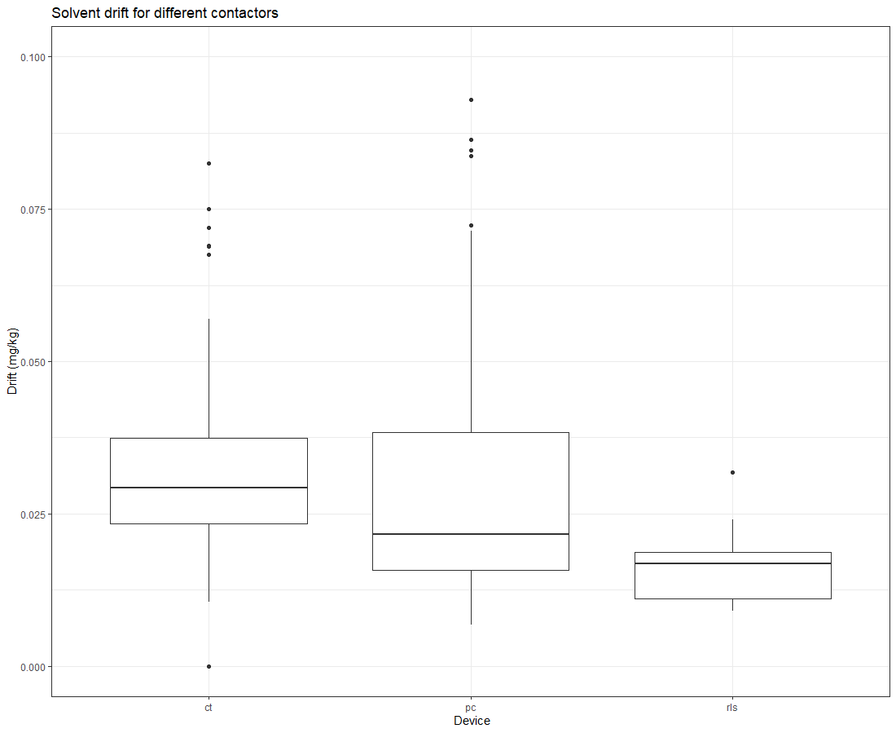

Figure , the effect of using different air capture devices on solvent drift

Figure 18 confirms the findings of the previous figure. The median diameter of particles emitted from the cooling tower is more than RLS and packed column which explain why drift from the cooling tower was more.

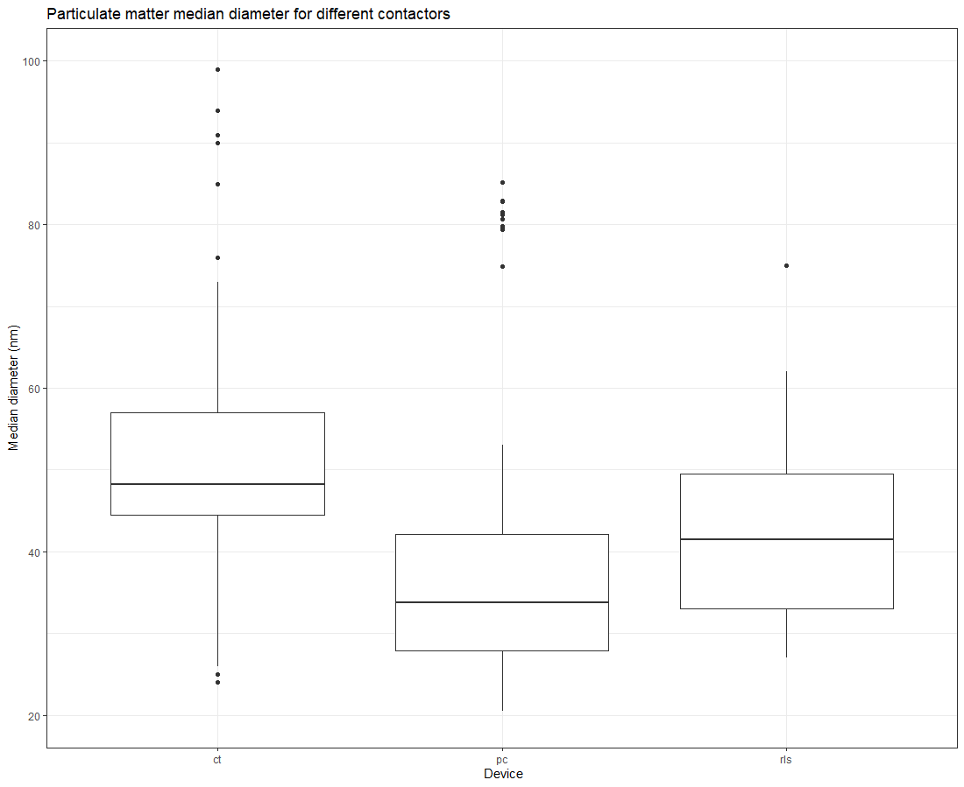

Figure , the effect of using different air capture devices on the particulate matter median diameter

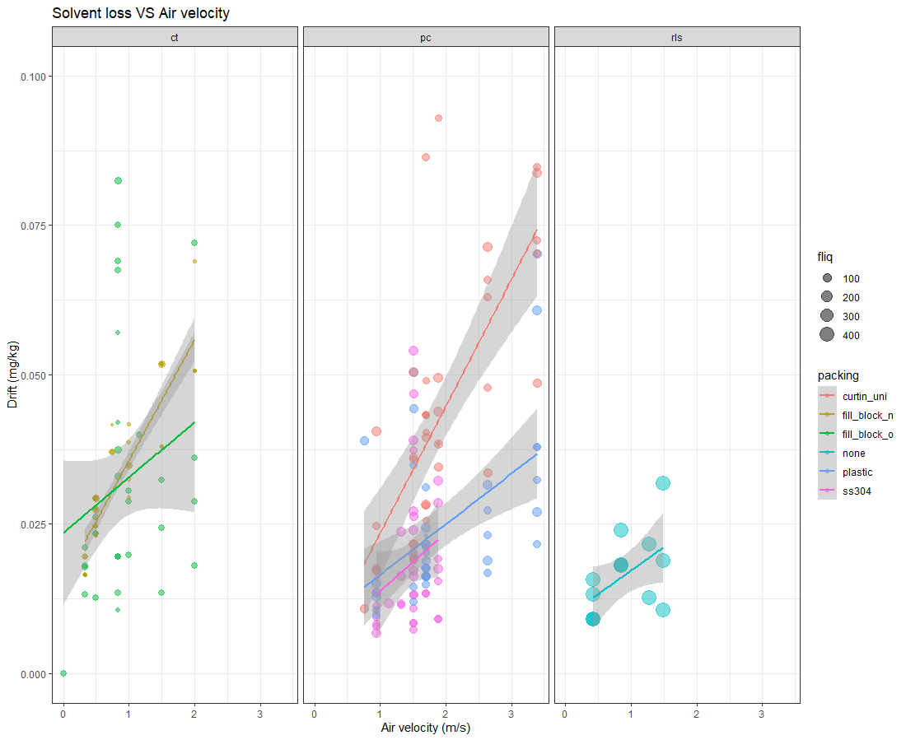 Figure , effect of intake air velocity on the drift for the three contactors

To sum up, figure 18 shows the effect of intake air on solvent drift categorised by the contactor, colour-coded by packing type and sized by the flow rate. It is seen that intake air velocity plays a key role in the drift. The flow rate of the solvent did not show a statistically significant effect on the drift. From the figure, it can be deduced that the cooling tower with the original fill-block and packed column with high flow plastic packing might be preferable over the other packings and contactors. The RLS flowrate was almost five times the highest flow rate in the packed column and almost ten times higher than that of the cooling tower. Stainless still packing showed that they will cause the smallest solvent drift, but they also caused the highest pressure-drop which limits the maximum achievable flow rate.

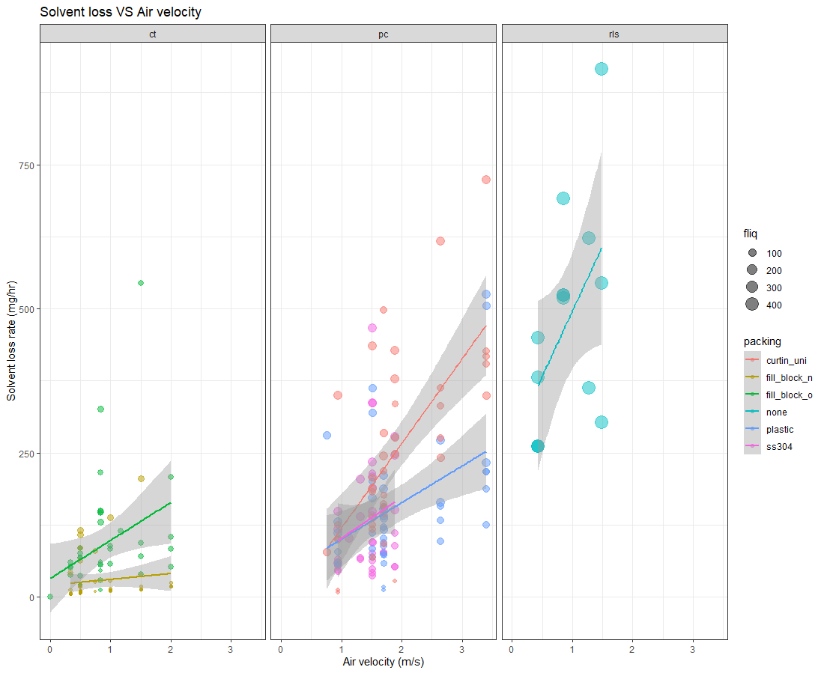

Figure Solvent loss rate VS airflow rate for different contactors

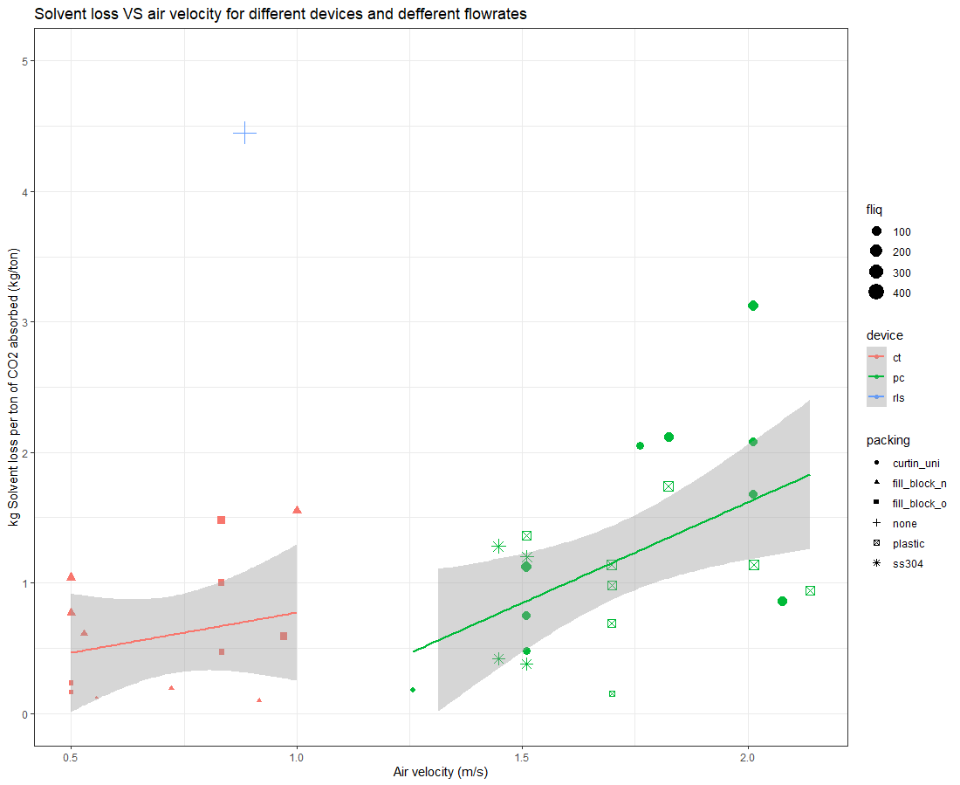

Figure

Table one shows averaged values for solvent loss, solvent drift and CO2 abrorbtion percentage for all tested cases. Rows are sorted iin descending order by the drift per ton of CO2 absorbed.

ct: cooling tower, pc: packed column, rls: rotating liquid sheet

fc: full cone, sp_3arm: sprinkler with three arms, hc: hollow cone, distbtr: the in-house design distributor used on packed column,

fill_block_o: cooling tower original fill block

fill_block_n: cooling tower new fill block

plastic: packed column high flow plastic random packing

ss304: packed comumn stainless still 304 random packing

curtin_uni: packed column structured packing

Table parameters affecting CO2 absorbtion and solvent loss

|  |  |  |  |  |  |  |  |  |  |  |
| --- | --- | --- | --- | --- | --- | --- | --- | --- | --- | --- |
| Device Type | Packing | Distributor | Solvent | Solvent Flowrate | Avg | Avg | Avg | Avg CO2 | Kg drift per ton of CO2 absorbed | Air  velocity |
| **Type** | **Type** | **Type** | **(lit/min)** | **Drift** | **Airflow Rate** | **Solvent Loss** | **Absorption** |  |  |
|  |  |  |  | **(mg/kg)** | **(m3/s)** | **(mg/hr)** | **(%)** | **(kg/t)** | **(m/s)** |
| ct | **fill_block_n** | **fc** | **taurate** | **5** | **0.0385** | **0.33** | **14** | **15.1** | **0.1** | 0.92 |
| ct | fill_block_n | sp_3arm | taurate | 5 | 0.0304 | 0.33 | 11 | 11.9 | 0.1 | 0.92 |
| ct | fill_block_n | sp_3arm | taurate | 3 | 0.0285 | 0.2 | 6 | 9.1 | 0.12 | 0.56 |
| ct | fill_block_o | hc | taurate | 5 | 0.0285 | 0.18 | 10 | 12.9 | 0.16 | 0.5 |
| ct | fill_block_n | sp_3arm | taurate | 10 | 0.0315 | 0.26 | 23 | 16.3 | 0.19 | 0.72 |
| ct | fill_block_o | hc | taurate | 10 | 0.0293 | 0.18 | 21 | 18.5 | 0.23 | 0.5 |
| ct | fill_block_o | hc | taurate | 15 | 0.0365 | 0.3 | 39 | 10.2 | 0.47 | 0.83 |
| ct | fill_block_o | hc | taurate | 40 | 0.0331 | 0.35 | 95 | 16.8 | 0.59 | 0.97 |
| ct | fill_block_n | hc | taurate | 30 | 0.0286 | 0.19 | 62 | 19.4 | 0.61 | 0.53 |
| ct | fill_block_n | hc | taurate | 40 | 0.0293 | 0.18 | 84 | 22.1 | 0.77 | 0.5 |
| ct | fill_block_o | hc | taurate | 30 | 0.05 | 0.3 | 108 | 13.1 | 1 | 0.83 |
| ct | fill_block_n | hc | taurate | 55 | 0.0293 | 0.18 | 116 | 22.4 | 1.04 | 0.5 |
| ct | fill_block_o | hc | taurate | 55 | 0.051 | 0.3 | 202 | 16.5 | 1.48 | 0.83 |
| ct | fill_block_n | sp_3arm | taurate | 55 | 0.038 | 0.36 | 150 | 9.8 | 1.55 | 1 |
| pc | plastic | distbtr | taurate | 10 | 0.0196 | 0.27 | 14 | 13 | 0.15 | 1.7 |
| pc | curtin_uni | distbtr | taurate | 10 | 0.0216 | 0.2 | 16 | 15.7 | 0.18 | 1.26 |
| pc | ss304 | distbtr | taurate | 70 | 0.0115 | 0.24 | 58 | 23 | 0.38 | 1.51 |
| pc | ss304 | distbtr | taurate | 80 | 0.013 | 0.23 | 75 | 27.8 | 0.42 | 1.45 |
| pc | curtin_uni | distbtr | caustic | 50 | 0.0192 | 0.24 | 69 | 21.8 | 0.48 | 1.51 |
| pc | plastic | distbtr | taurate | 50 | 0.0182 | 0.27 | 66 | 12.8 | 0.69 | 1.7 |
| pc | curtin_uni | distbtr | caustic | 80 | 0.0216 | 0.24 | 124 | 25.1 | 0.75 | 1.51 |
| pc | curtin_uni | distbtr | caustic | 100 | 0.028 | 0.33 | 202 | 25.9 | 0.86 | 2.08 |
| pc | plastic | distbtr | taurate | 80 | 0.0207 | 0.34 | 119 | 13.5 | 0.94 | 2.14 |
| pc | plastic | distbtr | taurate | 70 | 0.0212 | 0.27 | 107 | 14.7 | 0.98 | 1.7 |
| pc | curtin_uni | distbtr | caustic | 120 | 0.0216 | 0.24 | 187 | 25.1 | 1.12 | 1.51 |
| pc | plastic | distbtr | taurate | 120 | 0.0241 | 0.32 | 208 | 20.7 | 1.14 | 2.01 |
| pc | plastic | distbtr | taurate | 100 | 0.0189 | 0.27 | 136 | 16.1 | 1.14 | 1.7 |
| pc | ss304 | distbtr | taurate | 100 | 0.0288 | 0.24 | 207 | 26.2 | 1.2 | 1.51 |
| pc | ss304 | distbtr | taurate | 120 | 0.023 | 0.23 | 198 | 24.5 | 1.28 | 1.45 |
| pc | plastic | distbtr | caustic | 80 | 0.0348 | 0.24 | 200 | 22.3 | 1.36 | 1.51 |
| pc | curtin_uni | distbtr | taurate | 70 | 0.0509 | 0.32 | 257 | 17.3 | 1.68 | 2.01 |
| pc | plastic | distbtr | caustic | 100 | 0.051 | 0.29 | 367 | 26.4 | 1.74 | 1.82 |
| pc | curtin_uni | distbtr | taurate | 50 | 0.0491 | 0.28 | 177 | 11.2 | 2.05 | 1.76 |
| pc | curtin_uni | distbtr | taurate | 80 | 0.0459 | 0.32 | 264 | 14.4 | 2.08 | 2.01 |
| pc | curtin_uni | distbtr | taurate | 100 | 0.0374 | 0.29 | 270 | 15.9 | 2.12 | 1.82 |
| pc | curtin_uni | distbtr | taurate | 120 | 0.0525 | 0.32 | 454 | 16.5 | 3.12 | 2.01 |
| rls | none | spiral | taurate | 400 | 0.0164 | 0.25 | 473 | 15.4 | 4.45 | 0.88 |

## Environmental

### RLS

### Cooling tower

### Packed column

Smps plots

New particle gen

### Discussion

# Conclusion

# Nomenclature

tgin: Temperature of air at inlet

hgin: Relative humidity of air at inlet

tgout: Temperature of air at outlet

hgout: Relative humidity of air at outlet

ph: PH of the solvent

tliq: Temperature of the solvent

co2in: Carbon dioxide at the inlet (ambient CO2)

co2out: Carbon dioxide concentration in air at the outlet

dp: Pressure drop across the contactor (mm.wc)

vg: Air velocity (m/s)

dustrak: PM10 measured by TSI Dusttrak (mg/m3)

cmd: Particle median diameter (nm)

nc: Partocle number concentration (#/cm3)

mass: PM10 measured by TSI Aerotrak

ambpm: Ambient PM10 (mg/m3)

driftmgkg: Solvent drift (%)

loading: Solvent loading (fraction)

co2diff: Difference between inlet and outlet CO2 concentration

fliq: Solvent flowrate (lit/min)

packing: type of packing

medium: medium, either taurate or caustic

disb: Distributor type

device: Air capture device

# Appendix

## Correlations plots

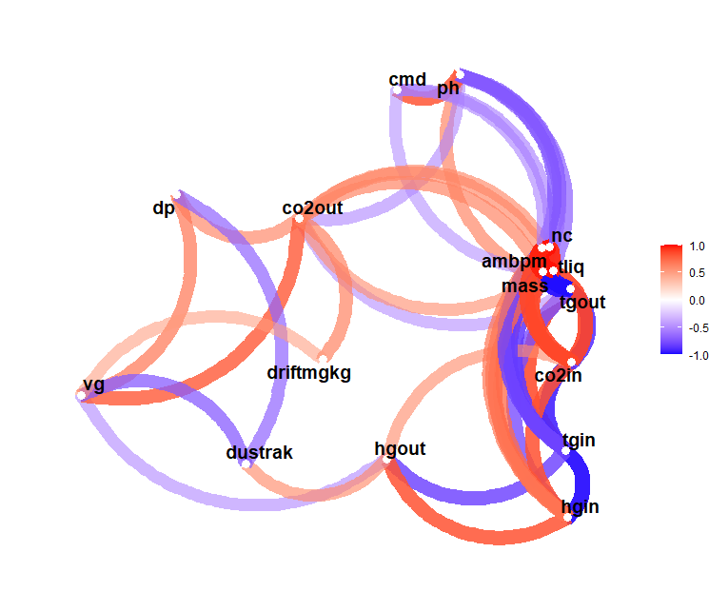

Figure . Correlation network diagram for RLS

The first plot shows a correlation graph of the variable and parameters recorded during the RLS operation. The plot is a network of a correlation data frame in which variables that are more highly correlated appear closer together and are joined by thicker paths. Paths are also coloured, blue for negative and red for positive. The proximity of the variable points is determined using multidimensional clustering methods.

The plot uses the Pearson Product-Moment Correlation Coefficient (PPMCC) to work out the correlations between variables. For the sake of simplicity, Figure 1 shows only correlations that are greater than 0.5.

There are correlations in the figure that are obvious and won’t be discussed; as such is the positive correlation between the inlet air velocity and pressure drop across the contactor. It can be seen that PM10 emissions have a negative correlation with that intake air velocity while solvent drift and air velocity have a positive correlation. The data points for RLS were not many and so some of the correlations that can be seen in the figure may represent a real relationship.

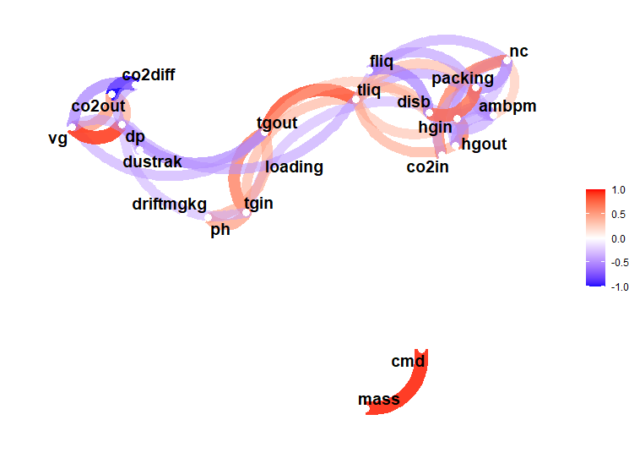

Figure The PPMCC network graph showing the possible correlations bewteen variables in the cooling tower. Only correlation inexcess of 0.5 are showin in the graph to prevent cluttering

Figure 21 illustrates the more significant correlations between recorded variables and parameters. The drift has a positive correlation with PM10 and also particulate matter emissions have a direct correlation with the median diameter of the particles. It can be seen in the figure that the type of packing and distributor affect the particle count, so they may affect the PM10 emission.

## Experimental setups

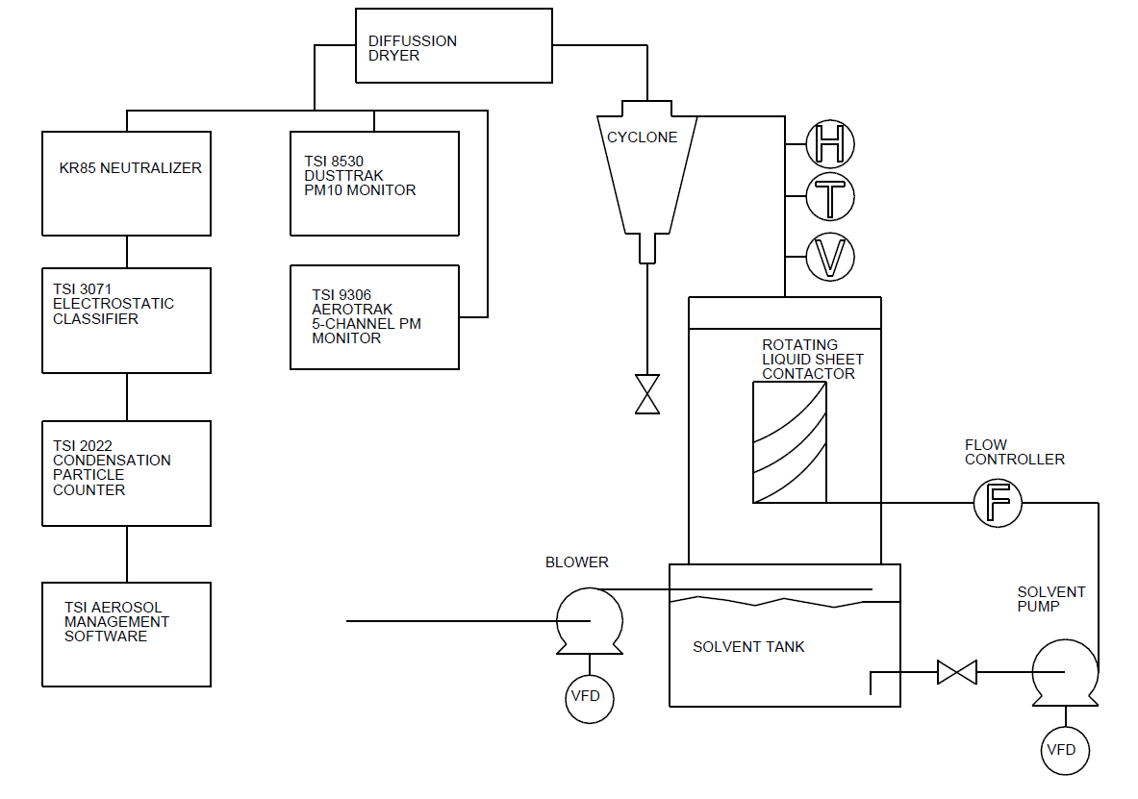

Figure , RLS expertimental setup

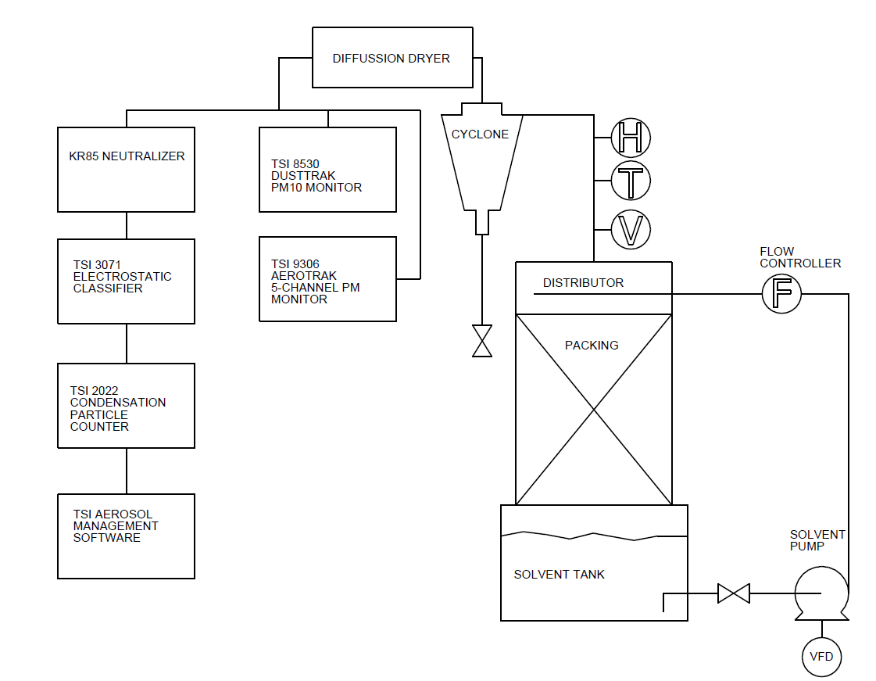

Figure , packed column experimental setup for both random and structured packings

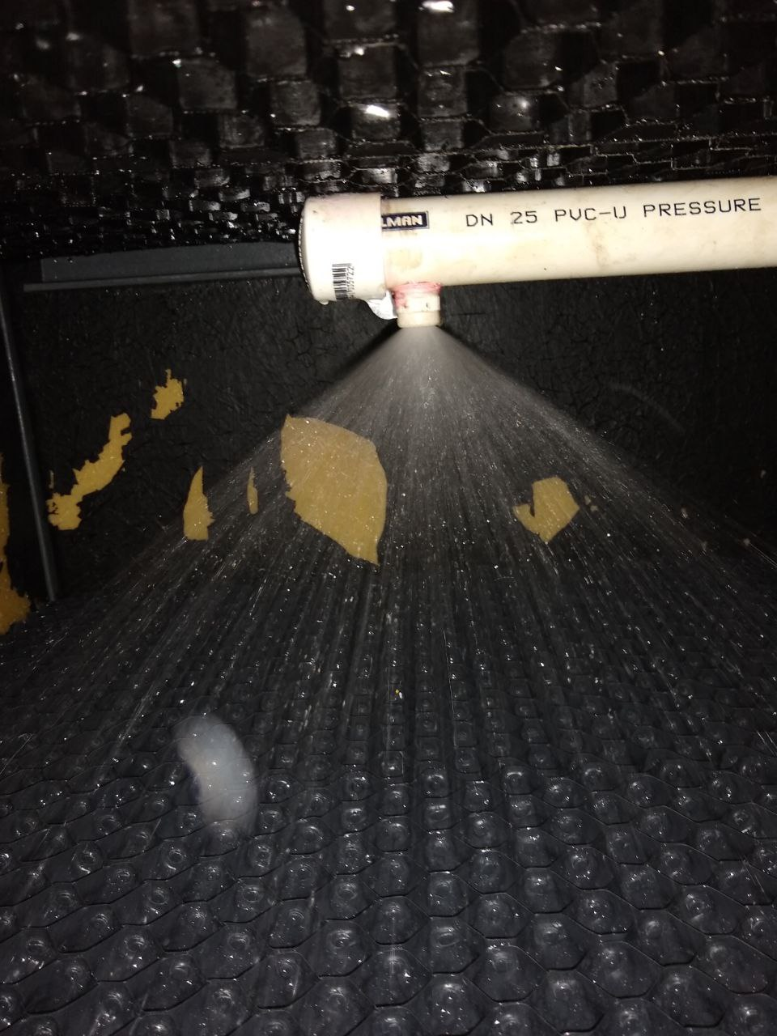 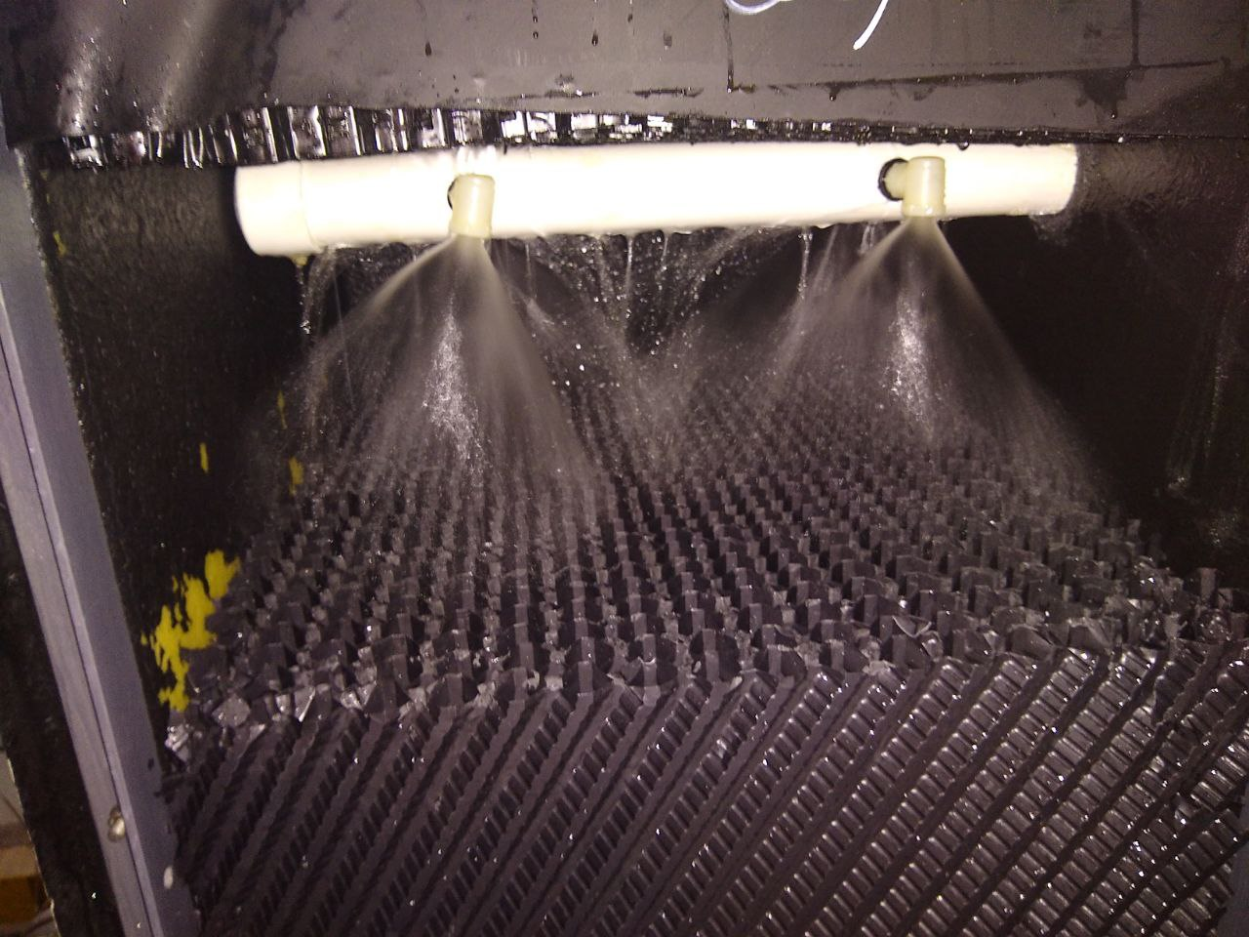

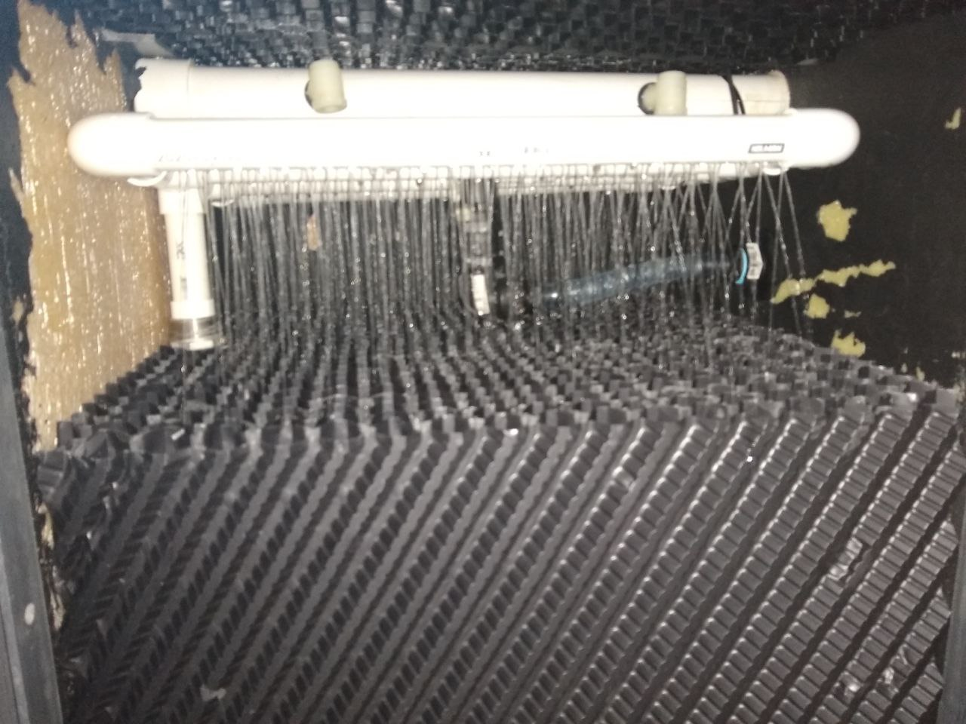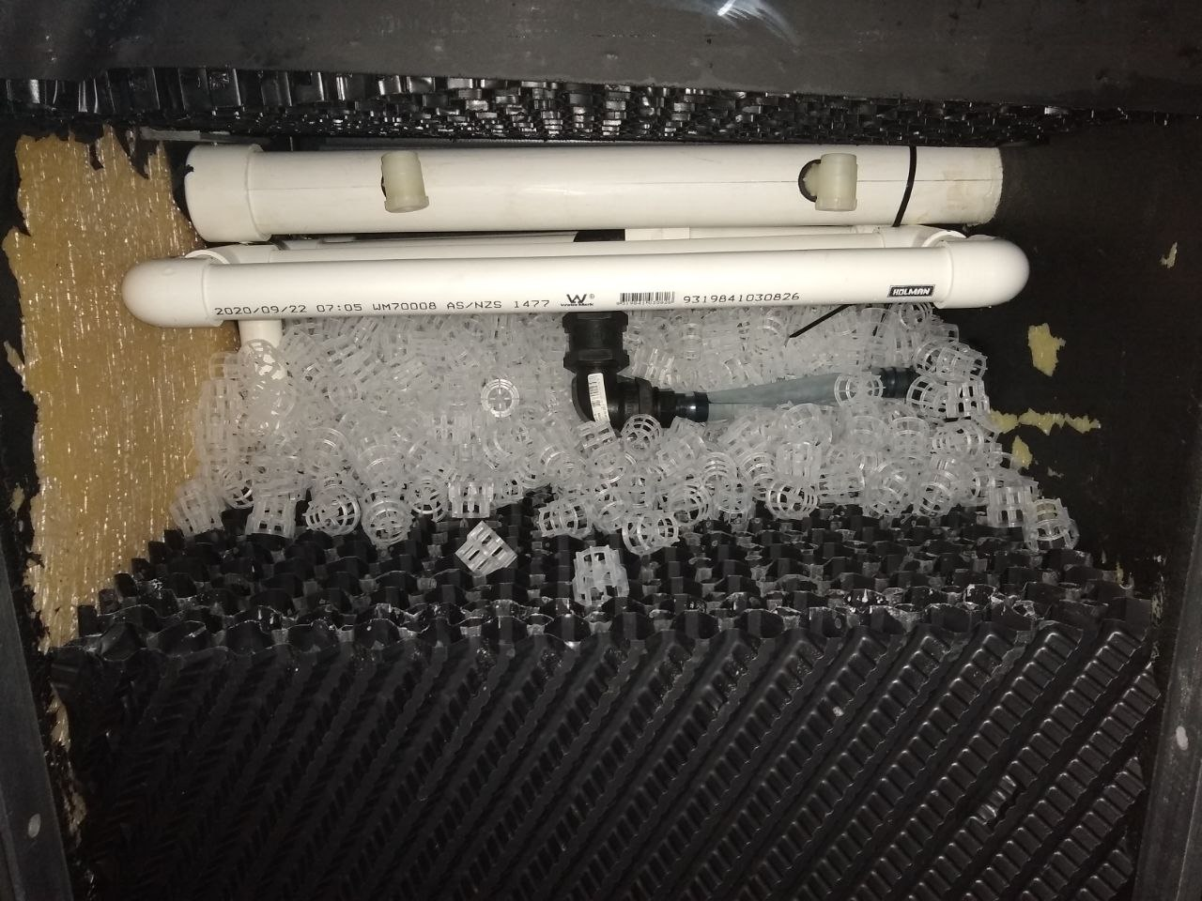

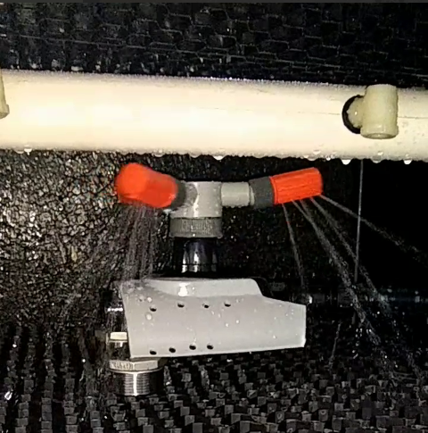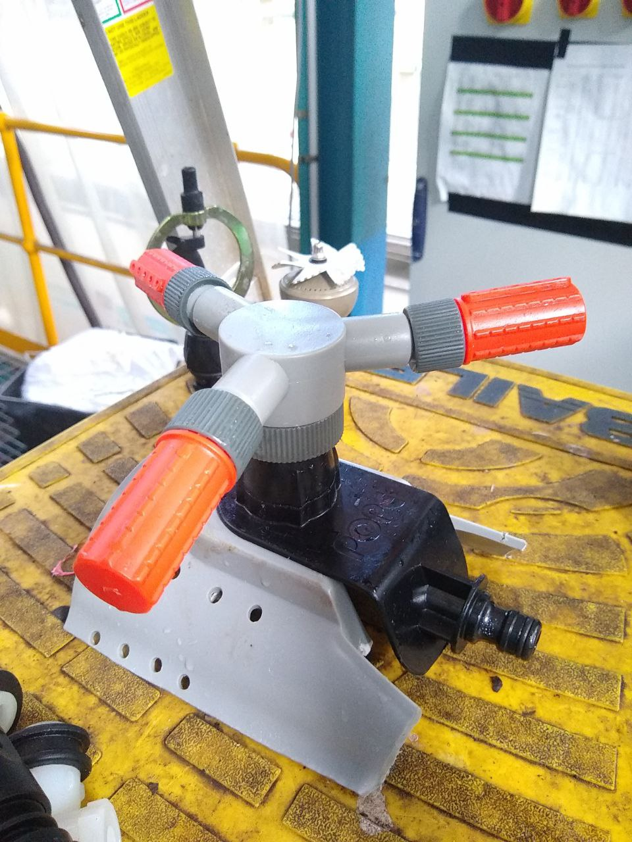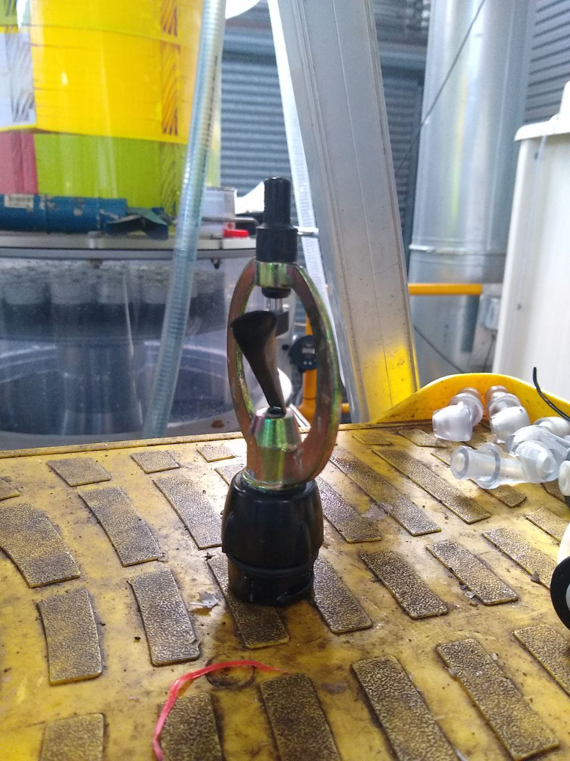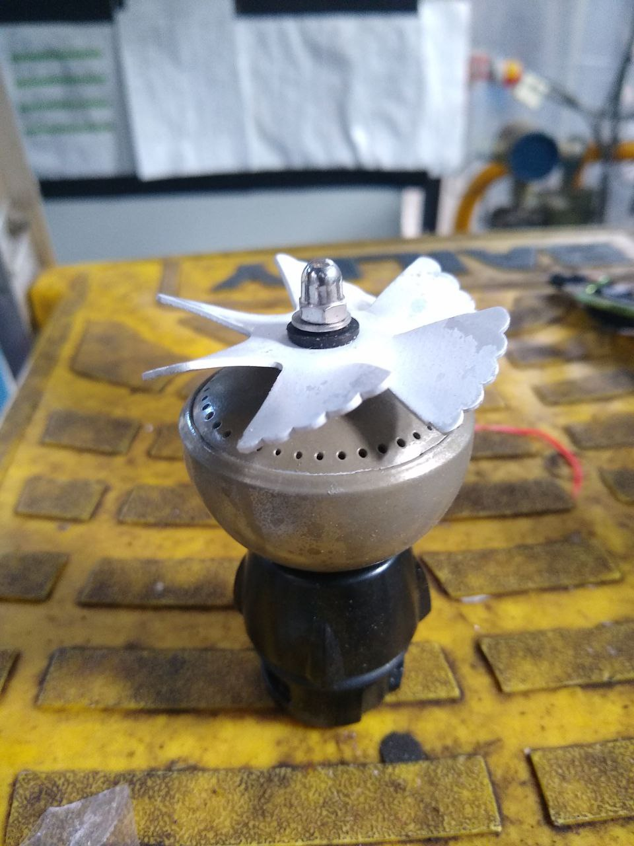

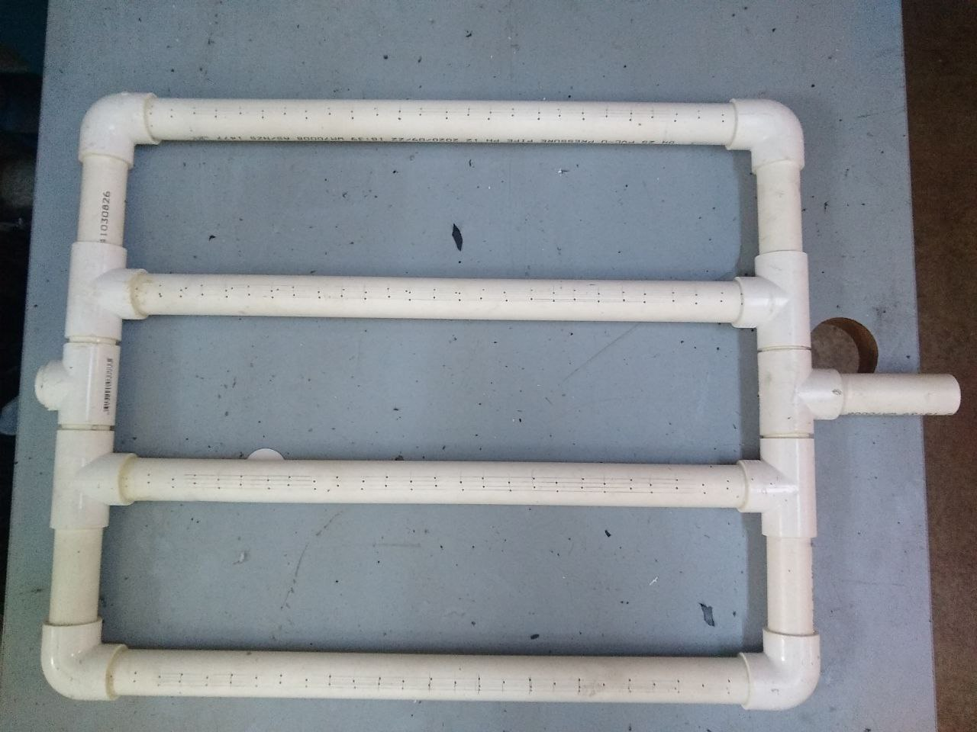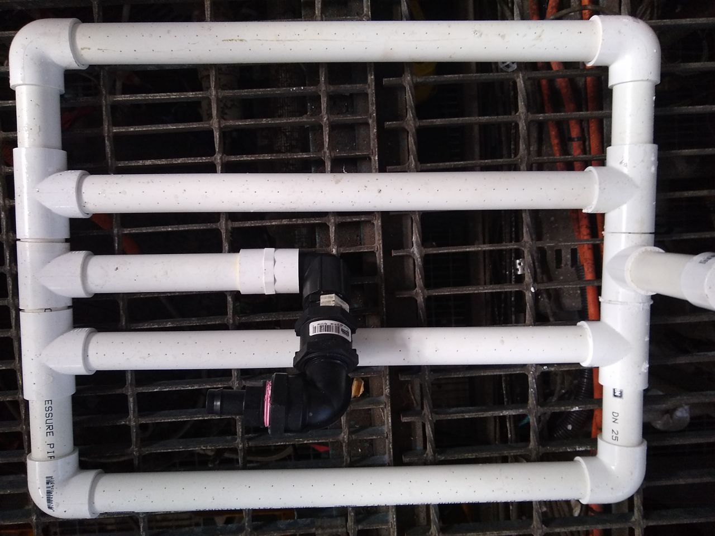

## External links

Link to the GitHub repository to access all codes and documents related to this manuscript:

<https://github.com/pourkhesalian/pm-analysis>

# References

1. Gaddis, E.S., *Mass transfer in gas–liquid contactors.* Chemical Engineering and Processing: Process Intensification, 1999. **38**(4): p. 503-510.

2. Haddad, P.R., *The encyclopedia of separation science.* TrAC-Trends in Analytical Chemistry, 2004. **23**(9): p. iii-iv.

3. Bhargava, A., *Wet scrubbers–design of spray tower to control air pollutants.* Int. J. Environ. Planning and Dev, 2017. **1**(1): p. 36-41.

4. Veltman, K., B. Singh, and E.G. Hertwich, *Human and environmental impact assessment of postcombustion CO2 capture focusing on emissions from amine-based scrubbing solvents to air.* Environmental science & technology, 2010. **44**(4): p. 1496-1502.

5. Lucas Miralles, M., P.J. Martínez Beltrán, and A. Viedma Robles, *Experimental determination of drift loss from a cooling tower with different drift eliminators using the chemical balance method.* 2012.

6. Song, Y., G. Wu, and B. Song. *Analysis of drift loss and concentration change of wet cooling tower*. in *IOP Conference Series: Earth and Environmental Science*. 2020. IOP Publishing.

7. Lucas, M., P. Martínez, and A. Viedma, *Experimental determination of drift loss from a cooling tower with different drift eliminators using the chemical balance method.* International journal of refrigeration, 2012. **35**(6): p. 1779-1788.

8. Ruiz, J., A. Kaiser, and M. Lucas, *Experimental determination of drift and PM10 cooling tower emissions: Influence of components and operating conditions.* Environmental Pollution, 2017. **230**: p. 422-431.

9. Mouchtouri, V.A., et al., *Legionella species colonization in cooling towers: risk factors and assessment of control measures.* American journal of infection control, 2010. **38**(1): p. 50-55.

10. FOUNDRIES, I., *BACKGROUND REPORT AP-42 SECTION 12.10.*

11. Saxena, P. and S. Sonwani, *Policy Regulations and Future Recommendations*, in *Criteria Air Pollutants and their Impact on Environmental Health*. 2019, Springer. p. 127-157.

12. Nicas, M., W.W. Nazaroff, and A. Hubbard, *Toward understanding the risk of secondary airborne infection: emission of respirable pathogens.* Journal of occupational and environmental hygiene, 2005. **2**(3): p. 143-154.

13. Wardhaugh, L.T., C.B. Solnordal, and A. Allport, *Design and performance of the rotating liquid sheet contactor.* Chemical Engineering and Processing: Process Intensification, 2017. **113**: p. 102-117.

14. Leimkühler, H.-J., *Managing CO2 emissions in the chemical industry*. 2010: John Wiley & Sons.

15. Tan, L.S., et al., *Factors affecting CO2 absorption efficiency in packed column: A review.* Journal of Industrial and Engineering Chemistry, 2012. **18**(6): p. 1874-1883.

16. Reisman, J. and G. Frisbie, *Calculating realistic PM10 emissions from cooling towers.* Environmental progress, 2002. **21**(2): p. 127-130.

17. Ruiz, J., et al., *Experimental measurement of cooling tower emissions using image processing of sensitive papers.* Atmospheric Environment, 2013. **69**: p. 170-181.

18. Kumar, D., et al., *4E (Energy, Exergy, Economic and Environmental) Analysis of the Novel Design of Wet Cooling Tower.* Journal of Thermal Engineering, 2020. **6**(3): p. 253-267.

19. Organization, W.H., *Hazard prevention and control in the work environment: Airborne dust.* 2002.

20. Nriagu, J.O., *Encyclopedia of environmental health*. 2019: Elsevier.

21. Perrino, C., *Atmospheric particulate matter.* Biophysics and Bioengineering Letters, 2010. **3**(1).

22. Pratsinis, S.E. and S. Vemury, *Particle formation in gases: A review.* Powder Technology, 1996. **88**(3): p. 267-273.

23. Naito, M., et al., *Nanoparticle technology handbook*. 2018: Elsevier.

24. Darquenne, C., *Aerosol deposition in health and disease.* Journal of aerosol medicine and pulmonary drug delivery, 2012. **25**(3): p. 140-147.

25. Kanakidou, M., et al., *Organic aerosol and global climate modelling: a review.* Atmospheric Chemistry and Physics, 2005. **5**(4): p. 1053-1123.

26. Kumar, P., et al., *A review of the characteristics of nanoparticles in the urban atmosphere and the prospects for developing regulatory controls.* Atmospheric Environment, 2010. **44**(39): p. 5035-5052.

27. Moser, P., et al., *Demonstrating emission reduction–results from the post-combustion capture pilot plant at Niederaussem.* Energy Procedia, 2014. **63**: p. 902-910.

28. Pena, J., J. Norman, and D. Thomson, *Isokinetic sampler for continuous airborne aerosol measurements.* Journal of the Air Pollution Control Association, 1977. **27**(4): p. 337-341.

29. Sioutas, C., *Evaluation of the measurement performance of the scanning mobility particle sizer and aerodynamic particle sizer.* Aerosol Science & Technology, 1999. **30**(1): p. 84-92.

30. McMurry, P.H., *A review of atmospheric aerosol measurements.* Atmospheric Environment, 2000. **34**(12-14): p. 1959-1999.

31. Chung, E.-K., et al., *Relationships between a Calculated Mass Concentration and a Measured Concentration of PM 2.5 and Respirable Particle Matter Sampling Direct-Reading Instruments in Taconite Mines.* Journal of Korean Society of Occupational and Environmental Hygiene, 2014. **24**(1): p. 65-73.

32. Ihaka, R. and R. Gentleman, *R: a language for data analysis and graphics.* Journal of computational and graphical statistics, 1996. **5**(3): p. 299-314.

33. Team, R. *RStudio: integrated development for R. RStudio*. Inc., Boston, MA 2021; Available from: <http://www.rstudio.com/>.

34. Harrison, R.M., R.E. Hester, and X. Querol, *Airborne Particulate Matter: Sources, Atmospheric Processes and Health*. 2016: Royal Society of Chemistry.

35. Kurth, L.M., et al., *Atmospheric particulate matter size distribution and concentration in West Virginia coal mining and non-mining areas.* Journal of exposure science & environmental epidemiology, 2014. **24**(4): p. 405-411.

36. Pearson, K., *Notes on Regression and Inheritance in the Case of Two Parents Proceedings of the Royal Society of London, 58, 240-242*. 1895, ed.

37. Benesty, J., et al., *Pearson correlation coefficient*, in *Noise reduction in speech processing*. 2009, Springer. p. 1-4.

38. Ji, Z., et al., *Experimental investigations on a cyclone separator performance at an extremely low particle concentration.* Powder Technology, 2009. **191**(3): p. 254-259.

39. Ter Linden, A., *Investigations into cyclone dust collectors.* Proceedings of the Institution of Mechanical Engineers, 1949. **160**(1): p. 233-251.

40. Mothe, H. and F. Loffler, *Prediction of Particle Removal in Cyclone Separator.* Int. Chem. Eng, 1988. **28**: p. 231-240.